UGM Guest Database Installation Guide
(also available here in MS Word format)
These are the steps you need to follow:
1) Install your server
2) Setup your server environment
3) Create security certificates (optional but recommended)
4) Update the server
5) Configure a backup system
6) View video tutorials
7) Setup reports
If you are familiar with Debian Linux and simply want to install into your own server, please go to https://github.com/UnionGospelMission/UGM-Database and follow the instructions in Install Instructions. Then go here to pick up this set of instructions again.
First, download the compressed disk image. This file is approximately 2 gb, so the download could take a while. Once you have it downloaded, unzip the file. Please be aware, you will need roughly 20 gb of space for the uncompressed image.
Next, install VirtualBox from https://www.virtualbox.org/.
Start VirtualBox and click New
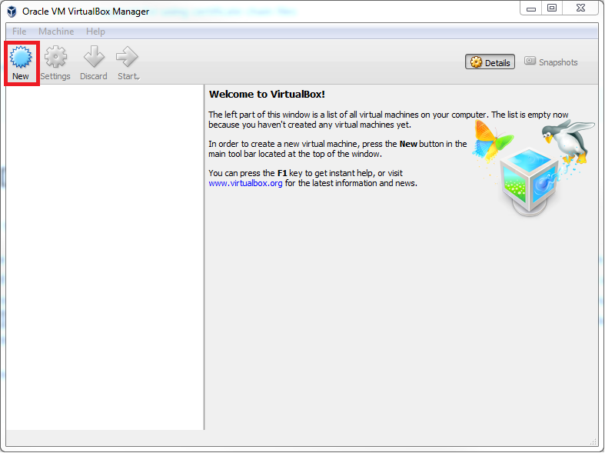
Enter a name, type, and version. Set the memory to at least 2048, preferably 4096 if available. Select use and existing virtual hard disk file, and click the folder select. Navigate to where you unpacked your download, select the ugmvm.vmdk file and click open. Then click create which was previously greyed out.
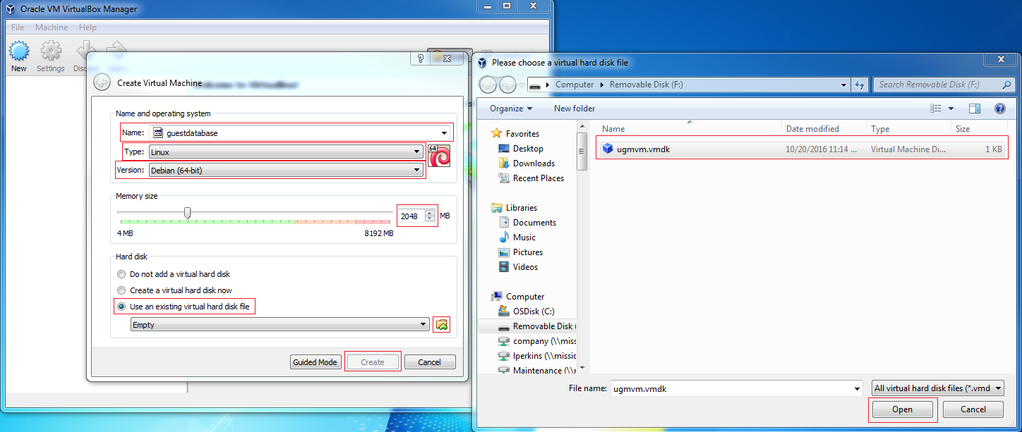
Make sure the new vm is highlighted and click settings.
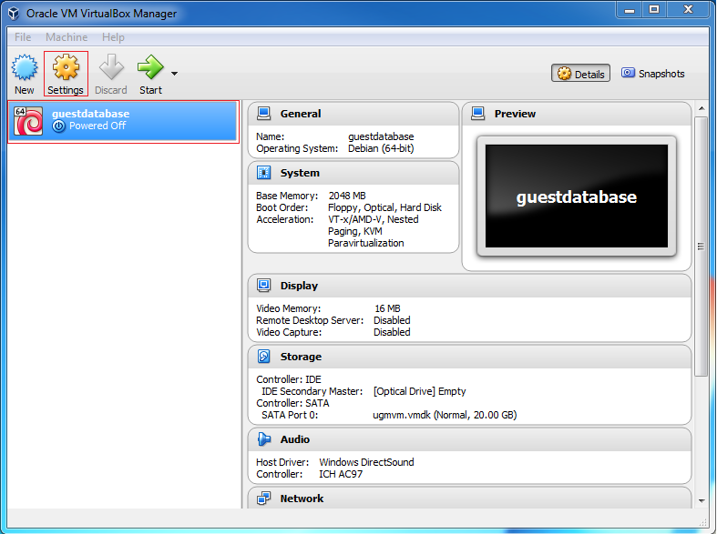
Select the network settings, set attached to be bridged adapter, drop down advanced, select allow all under promiscuous mode, and click ok.
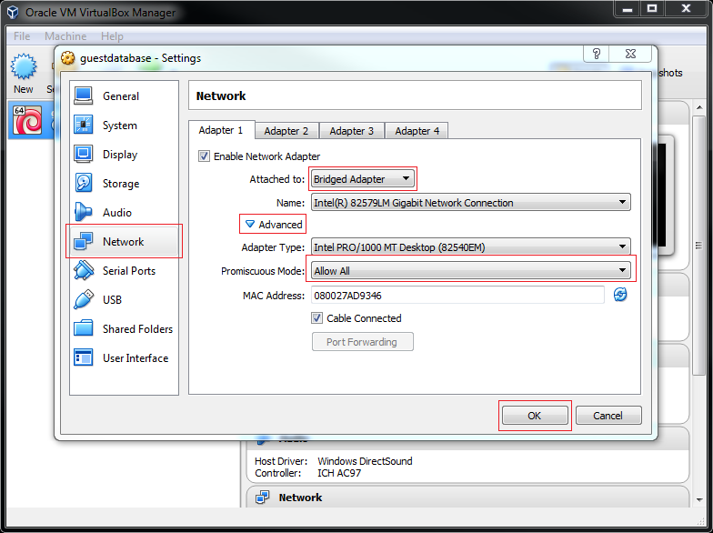
Click Start
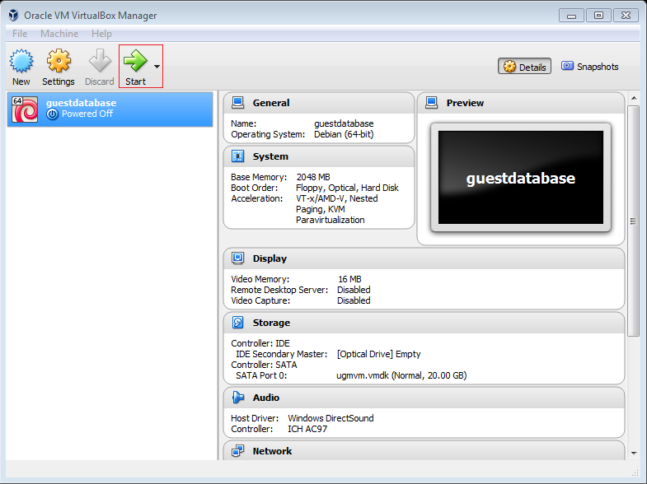
Congratulations, you now have a working virtual server.
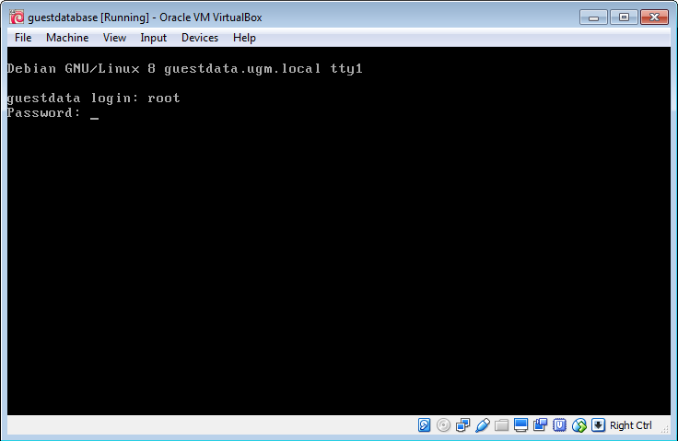
You might get some notices on the login, don’t worry about them. Now you can use the login “root” and “xyzzy” without the quotes. Don’t worry, you’ll change the password in a little while, after we set up the database with your own security certificates and passwords that will be unique to your organization.

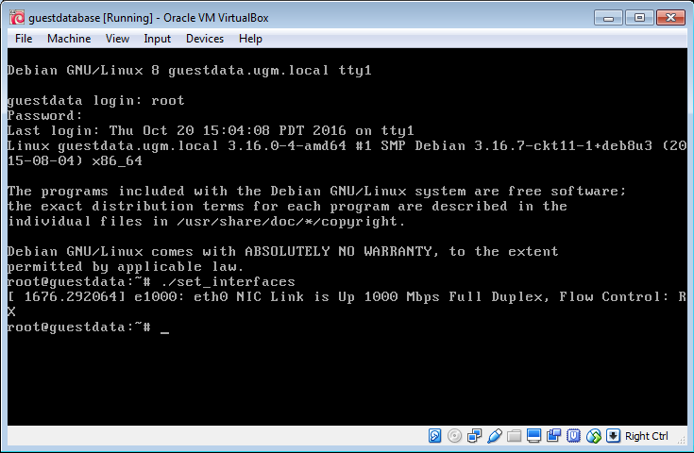
Type ./set_interfaces and hit enter. This will run an automatic script that will activate your virtual machine’s connection to your network. You will need to re run this script every time you restart the server.
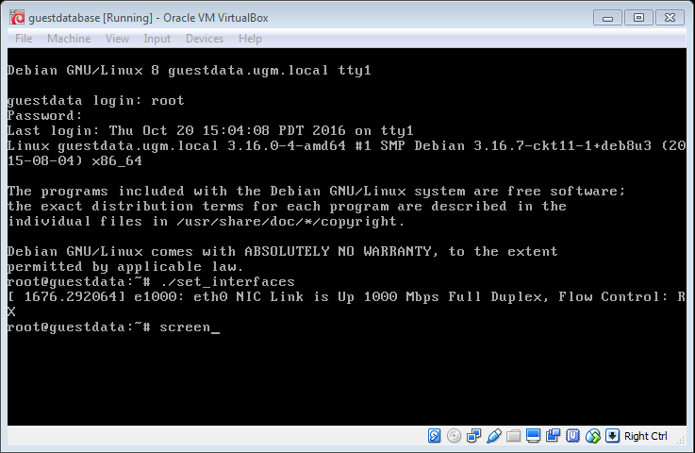
Now run screen. Screen is a program that allows you to have multiple terminals (the black screens you’re typing into) open at the same time. It can be handy to be able to switch to other tasks without disturbing what you’re working on. Screen also lets advanced users connect from other machines to share workspaces. 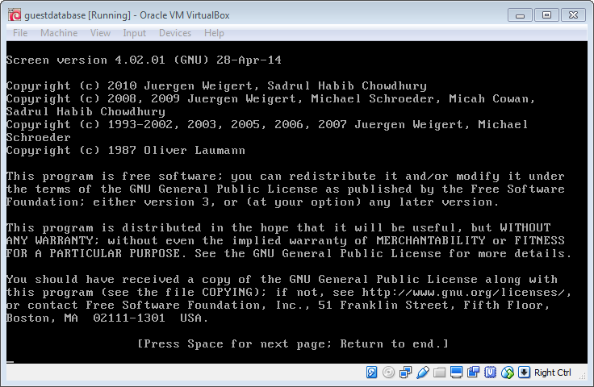
Regardless, you will get an introduction page which you can just hit enter through (or you can read it).
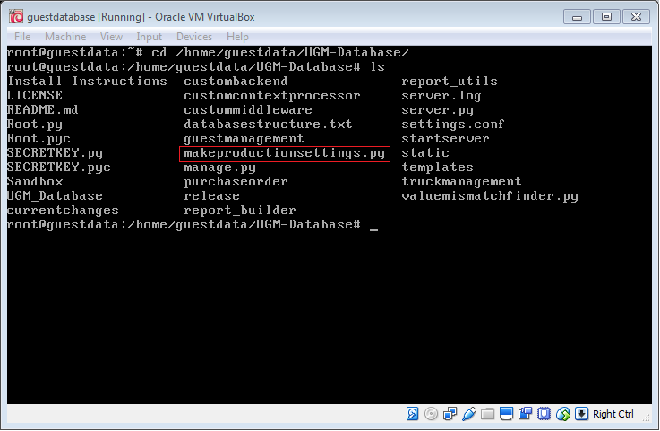
Alright, I am going to start going a little faster. I am assuming you have figured out how to enter commands, so I will just explain what to run and show you the result of several commands at a time. The first group is to run “cd /home/guestdata/UGM-Database/”. This will Change Directory to the core of the database. Then you run “ls” to get the screenshot above. Notice the makeproductionsettings.py highlighted above (the red box won’t be on your screen, but the file should be listed). This is what you are going to run next, but also notice the startserver file. This will be your shortcut to start the server once we have configured it. Finally, the manage.py file is what you will use when the database needs maintenance after any system updates requiring a database migration. Such updates are clearly marked in the release notes. We will cover all that in a little while.
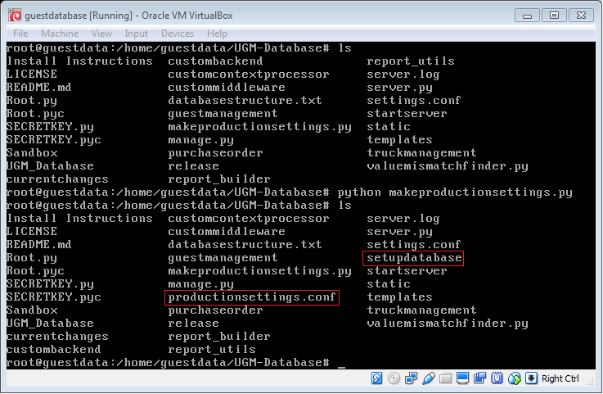
Now run “python makeproductionsettings.py” followed by “ls”. This will build your server’s basic productionsettings.conf. This is a file which is unique to your server and contains the information on connecting to the database behind the scenes. Don’t worry about how that works for now, the file is automatically generated correctly if you also got a setupdatabase out of the ls command.
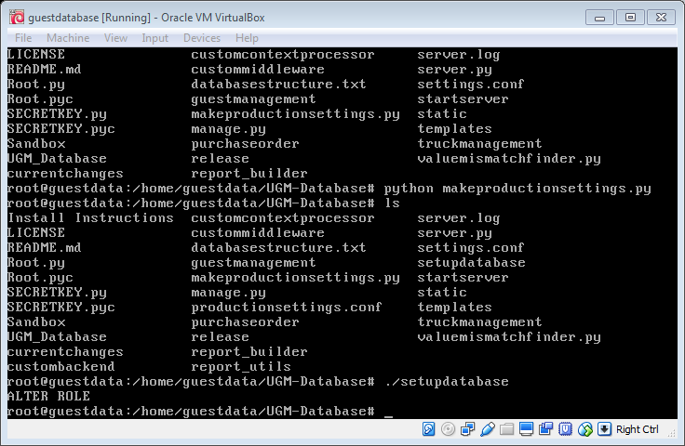
Now, run “./setupdatabase” and you’ll have a configured guest database server.
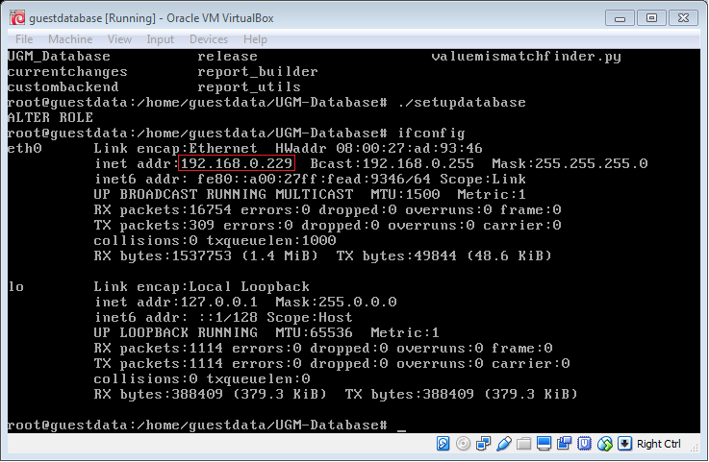
Before you start the server, though, run “ifconfig”. The inet addr is the address of the server. This system is currently using DHCP, which will probably work for you forever, but if that number changes, you’ll have to come back and set up a static ip. If you don’t understand any of that, talk to your IT person, or (if you are the IT person) you can either follow the instructions on setting up a static ip now, or cross that bridge when it becomes an issue. Regardless, your connection to the database from any webbrowser other than Internet Explorer is going to be https://[the ip address]/ (in this case 192.168.0.229, but that will be different on your system).

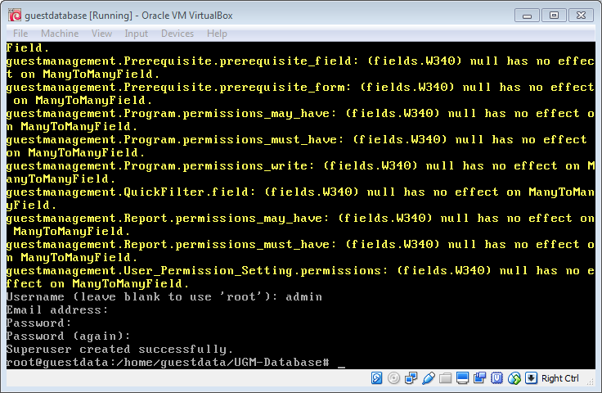
Now run “python manage.py createsuperuser” (the command is off the top of the screenshot). You will get a bunch of yellow text, don’t worry about it. Enter a username (I picked admin) an email address if you want, a password (which won’t show up as you type, but it is working), confirm the password, and you’ll have a superuser.
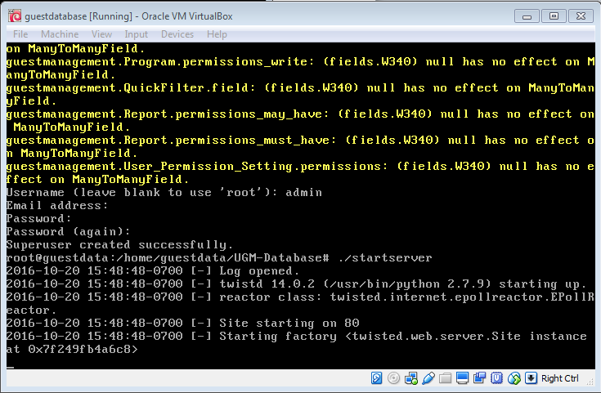
Now run “./startserver” and if you get output looking like this, you’re off to the races.
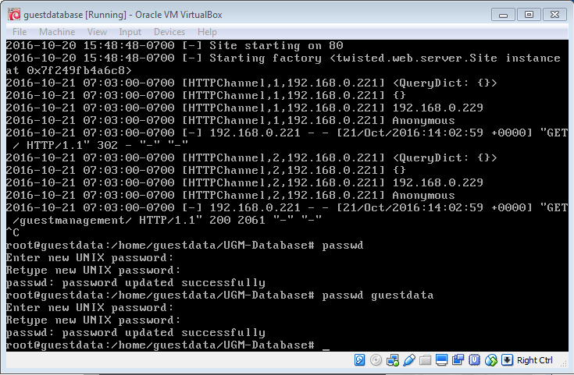
Before you actually start using the system, though, stop the server by hitting CTRL+c. Then run “passwd” and change the root password. Note, if you lose this password there is no way to recover it. Next run “passwd guestdata” to change the guestdata password.
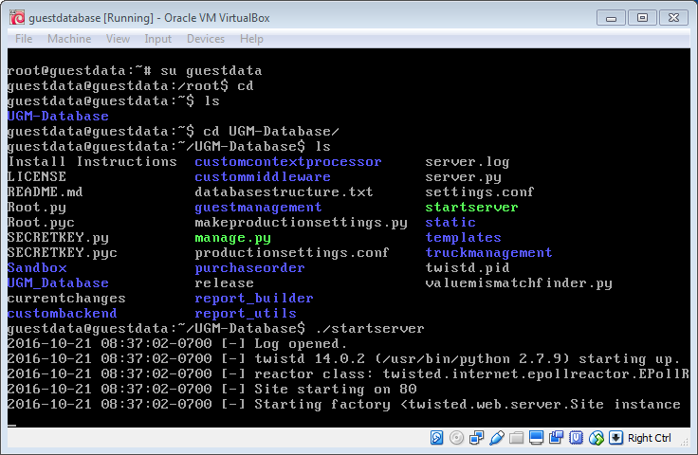
Finally, run “exit” (which is off the top of the screen) and you’ll be back to the guestdata user in the UGM-Database folder where you can run “./startserver” and now you’re ready to connect. Please go watch the video tutorials for how to use the system in general. Also see the report instructions for some basic report building block templates you can use.

Self-Signed Certificates
If you are going to enable offsite access to your database, you will need to get a web domain and appropriate security certificate. This is beyond this instruction set, so go get your certificate from wherever you want and skip down to where we plug the certificate into the server. For anyone using a self-signed certificate, this will walk you through how to create the certificate and configure the server to use it.
First start your vm and log in as guestdata.
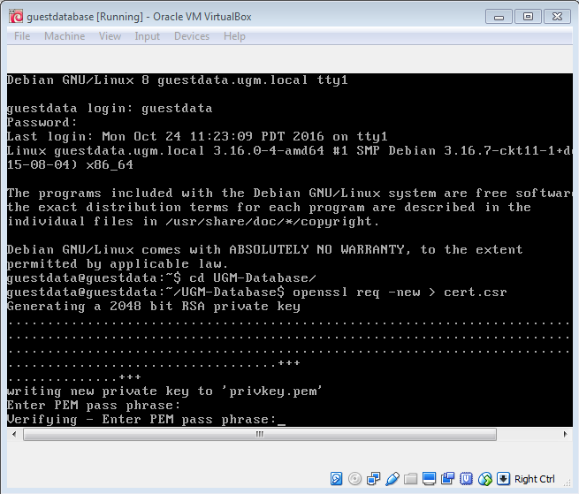
Now change directory to the database “cd UGM-Database” and run “openssl req –new > cert.csr”. This will start the process of generating a new certificate. When it asks for a pass phrase, put something in, but be sure to remember what you used. It will ask you to verify the pass phrase by typing it in twice.
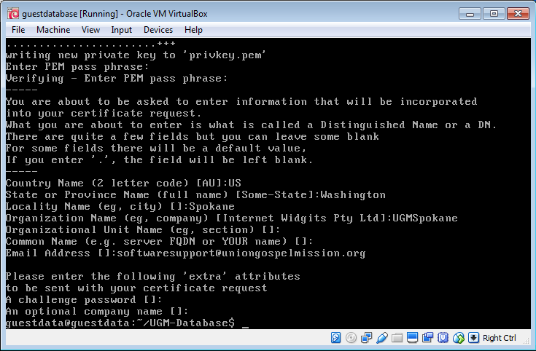
Next, you’ll be asked for some information. Enter your country name, state name, city, company name, and email address (the other two are optional). Be sure to leave the challenge password blank (unless you want to have to enter a password every time you start your guest database). Hit enter on each line until you get a screen as shown above (only with your information). You now have a new certificate.
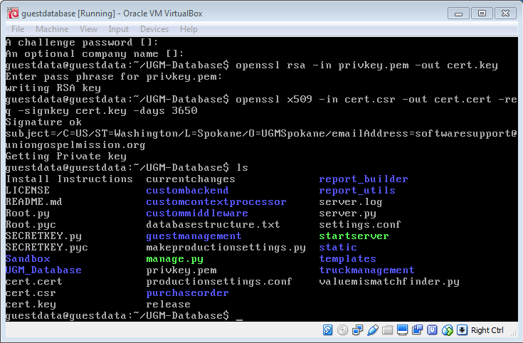
Next, run “openssl rsa -in privkey.pem -out cert.key” followed by “openssl x509 -in cert.csr -out cert.cert -req -signkey cert.key –days 3650”. Running “ls” now shows cert.cert, cert.csr, cert.key, and privkey.pem files.
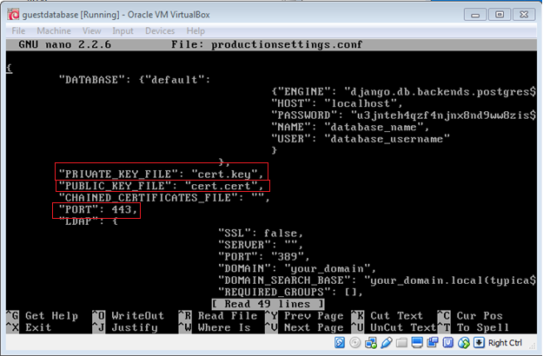
Now, run “nano productionsettings.conf” and enter cert.key and cert.cert between the quotes on the PRIVATE_KEY_FILE and PUBLIC_KEY_FILE lines respectively. Also change the port to 443. Hit CTRL+x to exit, answer “y” when asked if you want to save and hit ENTER when it asks for a file name.
Finally, run “chmod 500 cert.key” followed by “chmod –x cert.key” to make the private key only readable by guestdata.
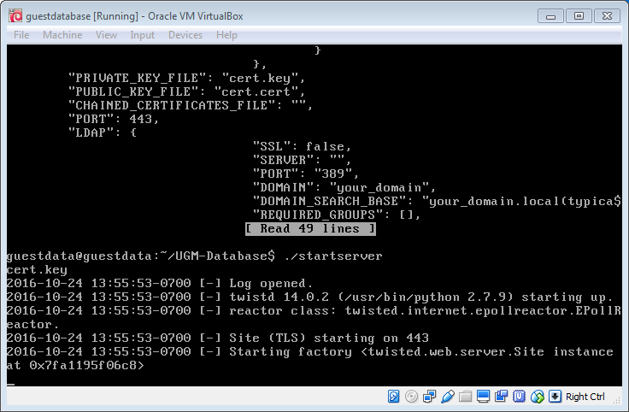
Running “./startserver” should fire up the web server on port 443 using the certificate you provided. If you are using a self-signed certificate, when anyone goes to connect, they will get this
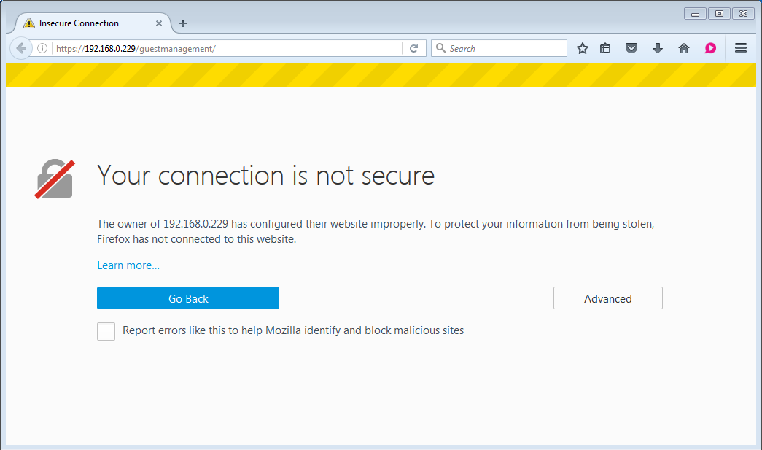
You’ll either need to have your IT person create an internal certificate authority, or just add an exception to your browsers to allow this connection. While we recommend the former practice, that process is beyond the scope of this instruction set and the latter will be sufficient for small networks. Again, if the database is accessible from the internet, a security certificate from a recognized authority is strongly recommended.

Database updates.
If you log into the database and see
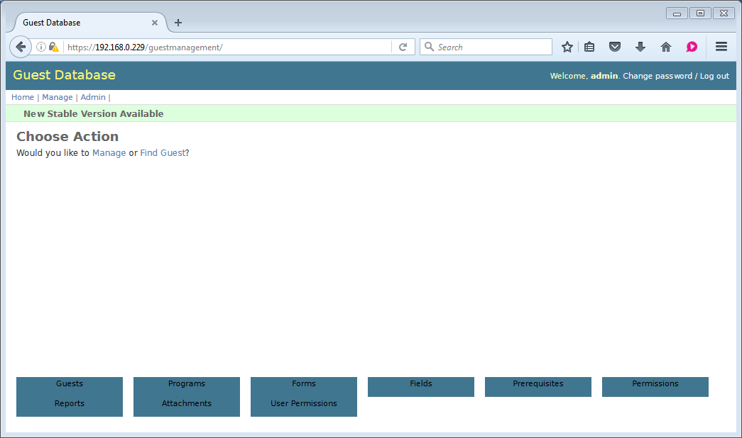
Or
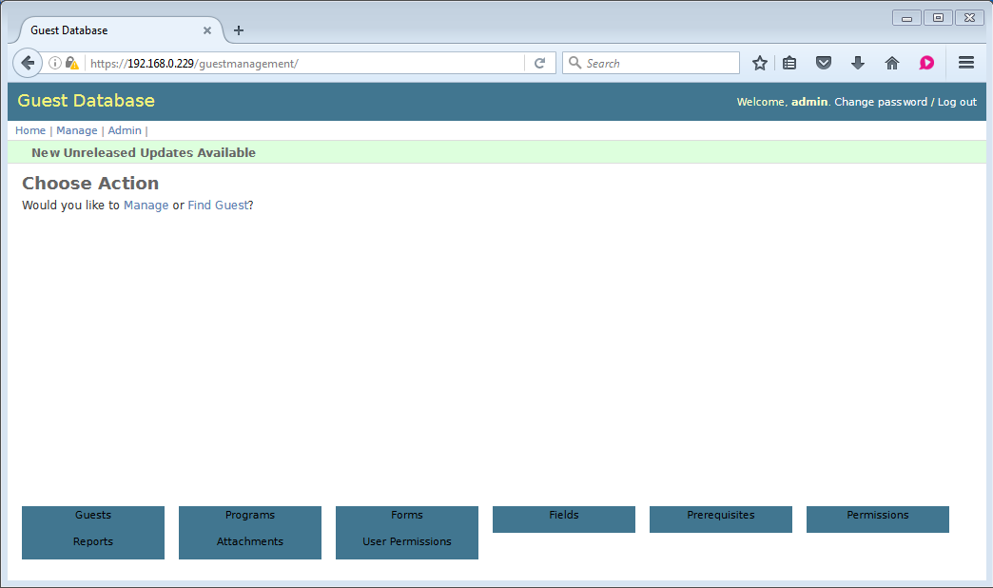
That means there have been updates to the database system. The former means either enough changes have been made to warrant a revision update, or, more commonly, there has been a major bug/security fix that you will want. Check the “currentchanges” file for what’s new. Unreleased updates are typically fairly minor and may or may not be worth updating. Again, check the “currentchanges” file to decide if you want to update.
Assuming you decide the changes are enough to need to update your system, first log in as guestdata and stop the server (hitting CTRL+c will stop the server. If it hasn’t stopped after ~5 minutes, go to a new terminal and run “kill -6 `cat twistd.pid`” from the UGM-Database directory.
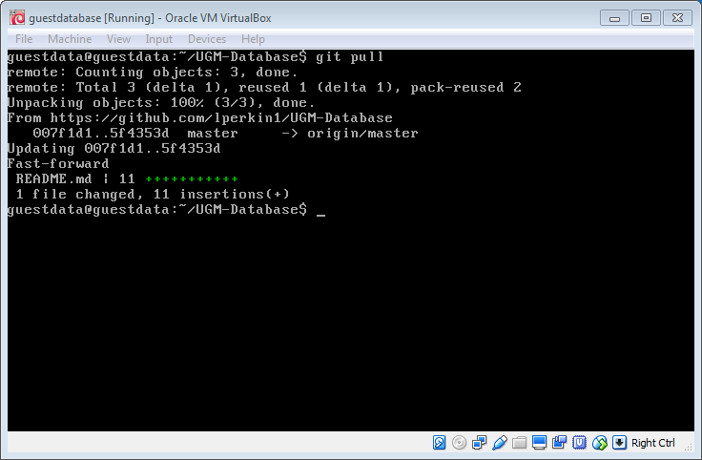
Run “git pull”. Any updates will be downloaded. If there are no changes, you will get an “already up to date” message. Once in a while, an update will include a change to the underlying database structure. You can find the changes in the currentchanges file by running “nano currentchanges”. When an update calls says **migration required** you will need to do a migration.
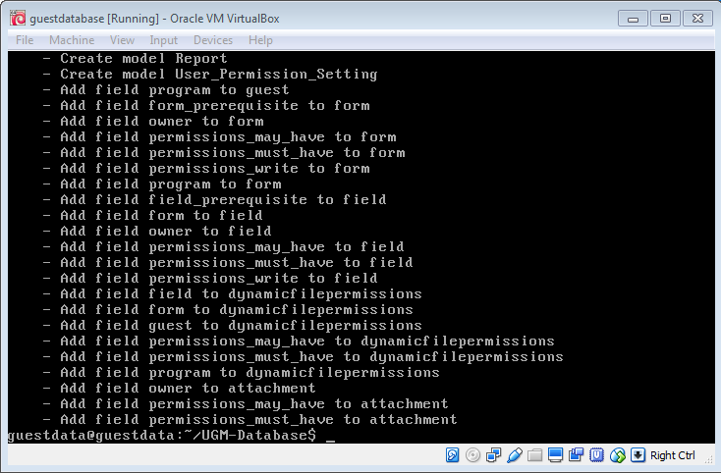
Run “python manage.py makemigrations guestmanagement” (which is off the top of the screen) and you will see a list of the changes to the database. You will also be given a number (in this case 0001, which is off the top of the screen, but which you can also find by running “ls guestmanagement/migrations” and taking the highest number) which you will use to run “python manage.py sqlmigrate guestmanagement ****” (in this case 0001)
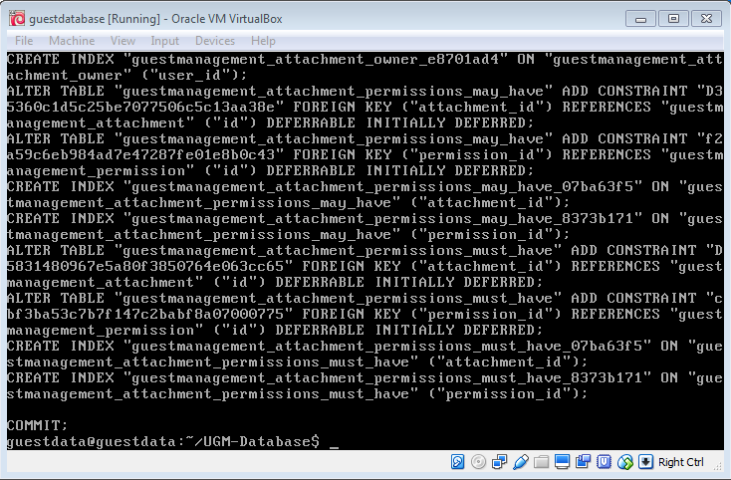
This will spit out a list of sql commands it will run on the database to configure your data for the new layout. Finally, run “python manage.py migrate guestmanagement” to actually commit the changes.
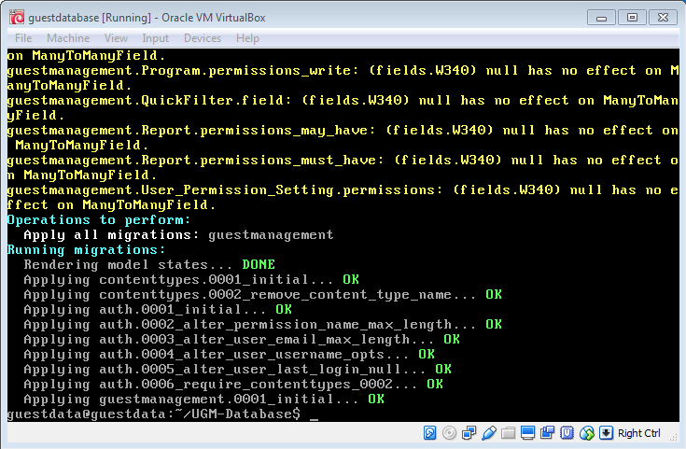
You can now restart the server with the “./startserver” command and your database is up-to-date.

Backups
If you used the virtual image to install, follow these instructions. Otherwise, I am assuming you can create your own backup and restore feature. To give you a hint, postgresql can create a command dump (as the postgres user, run “pg_dumpall –clean > <file_name>”) which will create a list of instructions required to entirely recreate the database. That, combined with the contents of “<database_directory>/static/media” is all you need to have a backup of the database. I just have a bash script that runs the command, then compresses and zips the contents of the media folder with the output of the postgresql command. To restore, the media folder gets copied back into the server, and the postgresql commands get fed to psql. You can find postgres documentation online readily enough.
For those using the disk image, as root, run “cd”, then run “python setupdatabasebackup.py”. This will create the bash script (in databasebackup) for you to run when making a backup. If you examine the contents of the file (either “nano databasebackup” or “cat databasebackup”) you will see a “-k” followed by a long string of random numbers and letters. You will want to not lose this. When your backups are created, they are encrypted with this passphrase so you can store the backups on a different computer. Without this passphrase, you will never be able to restore the backup. If you run “restorebackup”, you will be asked for this passphrase.
Now, having run this command, a database backup will be taken every night at 11:00 which will output in /media/backups. You’ll want to set up a way to move these backups to another computer, but that is outside the scope of this instruction set. Whatever you come up with for a backup system, be sure to test it (take a full backup, then restore the backup from its final storage) before you start storing important information in the database.
Database Video Tutorials
If you were successful with the previous instructions, you should now be able to use your database. You can download and view these video tutorials to see how to use the database. Your windows media player should play the videos, if not use vlc player (http://www.videolan.org/vlc/index.html).

Report examples

